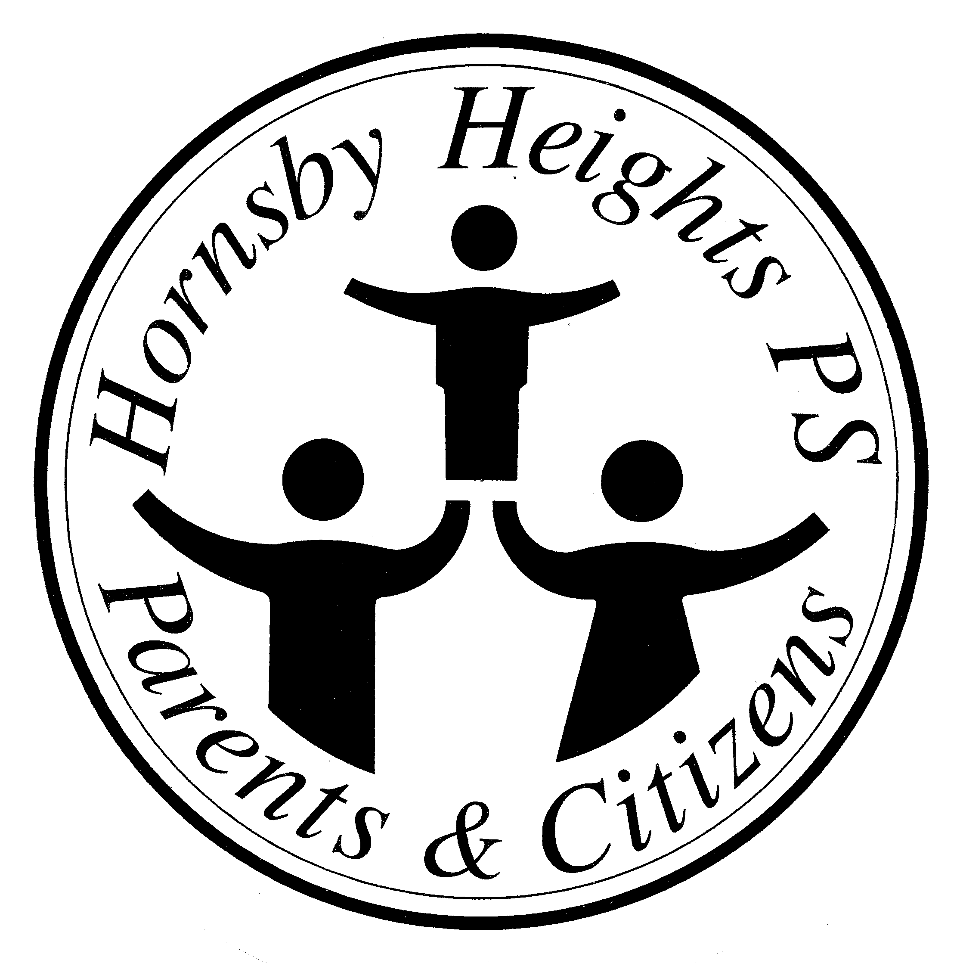
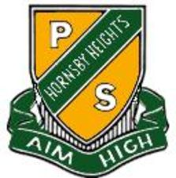 Hornsby Heights Public School
P & C Association
Somerville Rd Hornsby Heights NSW 2077 E-mail: hornsbyhts-p.school@det.nsw.edu.au
www.hornsbyhts-p.schools.nsw.edu.au

Hornsby Heights Public School P&C Communication Strategy
Purpose: The communication strategy outlines the key communication channels used by the Parents and Citizen’s (P&C) committee to communicate its actions and functions to the wider school community.
Related Policies/Documents:
- Social Media Policy
- Roles and responsibilities of the P&C Positions

There are eight (8) key communication channels used by the P&C.

- HHPS P&C Facebook page: This dynamic communication channel provides a people who are not physically proximate (i.e face-to-face) capacity to stay connected. It enables the P&C to post information to followers of the page, to be read at the follower’s leisure.

KPIs:
- President to post to Facebook monthly meeting agenda +/- key P&C events at least two (2) days prior to the meeting and/or event
- President to post to Facebook short general summary of key Monthly meeting items within 24 hours of the meeting taking place
- VP to trial setting up Facebook event for at least one Monthly P&C meeting to observe effect on attendance
- VP to trial ‘live posting’ of at least one Monthly P&C meeting
- Facebook admins to update HHPS P&C Facebook page with the ‘rules of engagement’.

- HHPS Information from P&C booklet: This static communication channel will act as a reference for new families to the school who receive the booklet at the time of kindergarten orientation and can then refer to the information at a later date. Basic information about the Committees and roles of the P&C are outlined in this.
KPIs:
- President to update booklet contents prior to orientation in 2014
- President to add link to HHPS P&C Facebook page to Page 1 of the booklet

- HHPS website: This communication channel provides key information on the world wide web. Its contents remain fairly static with opportunities to highlight key changes and/or projects.
KPIs:
- Secretary to add full list of P&C meeting dates for 2015 to the P&C page on the school website
- President to add a link to “Sign up to the P&C email feed” to P&C page on the school website
- President to review and update (as necessary) P&C page on the school website quarterly (once per school Term)

- eNews/email list: This dynamic communication channel enables the P&C to post documents, permission slips, invitations and reports to all subscribers. It is an opt-in/opt-out channel and is therefore reliant on parents signing up to be successful.
KPI:
- President, or delegate, to write quarterly summary report to be shared via eNews in Week five (5) of each school Term
- President to post P&C meeting agenda a least 2 days prior to scheduled meeting date

- HHPS Newsletter: Produced by the school, the newsletter offers an opportunity for the P&C to post short reports and updates on a fortnightly basis (if needed). It is delivered via eNews, email and uploaded to the HHPS website and is widely available to all school families.
KPI:
- Band, School Club, Eco-garden, School banking and Canteen Committees to submit content for inclusion in fortnightly newsletter

- P&C Noticeboard: Situated in the HHPS playground, the P&C Noticeboard is a fairly static communication channel. It is accessible to all visitors to the school and can be used to display photographs and documents that showcase the P&C activities at the school.
KPIs:
- Band, School Club, Eco-garden and Canteen Committees to showcase upcoming events, photos and news at least quarterly (once per school Term)

- School electronic noticeboard: Owned and operated by the school, the electronic noticeboard is visible to all passer-by traffic and pedestrians. It is a dynamic communication channel best suited to short ‘ad’-like messages, such as meeting dates.

KPI:
- President to liaise with the school Executive to market P&C meeting in the feed for 3-7 days prior to the monthly meeting date

- Annual School Report: This static communication channel is produced at the end of each year and highlights to successes of the P&C. It compiles many of the achievements of the P&C program in a succinct report that is published on the school website. It’s likely audience is current and new families to the school.

KPI:
- President to write annual summary statement by November for inclusion in the report (usually published in March the following year)
Evaluation:
- VP to audit communication strategy end 2015 and report to P&C Committee
- Communication strategy will be reviewed following audit and discussion at P&C meeting

Improving the educational experience of our children

